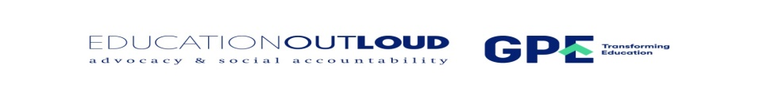

A GENDER AUDIT OF PRIMARY SCHOOL INSTRUCTIONAL MATERIALS IN ESWATINI

INTRODUCTION
The Swaziland Network Campaign for Education for All (SWANCEFA), in collaboration with the National Curriculum (NCC) conducted a comprehensive review of Competency-Based Education (CBE) instructional materials for Grades 1 to 7, with a specific focus on gender responsiveness. This activity aimed to assess how well gender issues are integrated and represented within the primary school curriculum, in line with Eswatini’s goal of providing inclusive and equitable quality education, as outlined in the National Education Sector Policy (2018). Furthermore, the review aimed to assess the alignment of instructional materials align with the gender-related aspects of the CBE syllabus. This would ensure that the curriculum not only acknowledges gender considerations but also actively promotes gender equality through its content, language, and intended learning outcomes.
This audit examines national and global initiatives, especially those highlighted in SDG 4 (Quality Education) and SDG 5 (Gender Equality), aimed at ensuring educational systems promote gender equity, challenge stereotypes, and create safe, inclusive, and empowering environments for both girls and boys.
The audit findings aim to support the review and revision of the curriculum, ensuring that the CBE instructional materials reflect gender sensitivity, equality, and empowerment across all learning areas. Additionally, the activity seeks to improve the abilities of curriculum designers to effectively assess and incorporate gender considerations into teaching and learning resources.
RATIONALE
Gender inequality remains a significant global challenge that continues to shape educational experiences and outcomes, including within the context of Eswatini. Educational materials that reflect gender bias, perpetuate stereotypes, or fail to represent the diverse identities and experiences of all learners contribute to systemic disparities and limit the realization of learners’ full potential.
The primary school phase, as the foundational stage of formal education, plays a critical role in shaping young learners’ perceptions of gender roles, norms, and expectations. It is during this formative period that children begin to construct their understanding of identity, relationships, and societal roles. Consequently, the messages conveyed through educational content and classroom practices at this stage can have a lasting impact on learners’ self-concept, interpersonal behaviours, and long-term aspirations, including their future academic and career choices.
Addressing gender inequality at the primary level is crucial for instilling lifelong values of respect, equity, and inclusion, laying the groundwork for a more just and balanced society. It enables both girls and boys to confront limiting norms and envision a diverse array of possibilities for their lives, free from traditional constraints and societal biases.
Through promoting gender-responsive education, Eswatini can advance both academic success and the broader objectives of social justice, equity, and inclusive development.
Purpose of the Audit
This curriculum audit aims to assess the presence and degree of gender bias in educational resources used in primary schools in Eswatini. By analyzing how gender is depicted across the Foundation, Middle, and Upper phases, The audit seeks to identify areas where instructional materials may reinforce stereotypes or fail to promote gender equality. The findings will inform recommendations for creating more inclusive and equitable learning environments that foster the overall development of all learners.

Objectives of the Audit
The specific objectives of the Audit were:
- To assess the representation of gender in educational resources across the Foundation, Middle, and Upper phases of primary education in Eswatini.
- To compare gender representation across the different phases of primary education to determine patterns or shifts over time.
- To provide evidence-based recommendations for improving gender inclusivity in primary school educational resources and practices.
METHODOLOGY
The NCC's curriculum designers conducted a gender audit of CBE materials for Grades 1 through 7. They used a systematic and participatory approach to ensure a thorough and contextually relevant evaluation of how gender responsiveness is integrated into the primary curriculum.
Development of the Audit Tool
A team of curriculum specialists developed a custom audit tool using gender documents to assess how gender is portrayed in CBE materials across different subjects and grades. The development of the tool was guided by national priorities, the CBE syllabus, and international best practices in gender-responsive teaching.
The Structure of the Audit Tool:
The audit tool (Appendix XX) was developed around five sections, which were:
Nature of Male and Female Characters, Illustrations, Settings, Language Use and Frequency of Appearance.

Data Collection and Analysis
Using the audit tool, curriculum designers conducted a detailed review of instructional materials for Grades 1 through 7. They worked together in small teams to assess and record the presence, frequency, and portrayal of gender elements based on the above criteria. Findings were documented using a standardized template to maintain consistency across grades and subjects.
The results were then compiled and analysed to identify recurring patterns, gaps, and opportunities for improvement. Qualitative observations were supported by quantitative data where applicable, such as counting the occurrences of male and female characters across instructional materials or comparing role types across subjects.
This comprehensive methodology ensured that the final report provides a complete and evidence-based summary of the status of gender responsiveness in Eswatini’s CBE instructional materials for the primary phase.
FINDINGS
The audit findings were organized according to the three main phases of primary school: Foundation, Middle, and Upper. Each criterion evaluated during the audit is presented within these phases to provide a clear and structured overview. To improve clarity and aid comparison, bar graphs are used to visually display the data, highlighting trends and differences across the various stages of primary education.
The Foundation Phase (Grades 1and 2)
In the foundation phase, seven subjects are offered: English, SiSwati, Mathematics, General Studies (GS), Expressive Arts, Health and Physical Education (HPE), and Religious Education (RE), along with Braille, Orientation and Mobility, Daily Living Skills, and Eswatini Sign Language. Each subject was evaluated to determine how well gender issues were integrated and represented.
The Middle Primary Phase (Grades 3 and 4)
In the middle primary phase, there are nine subjects. These include English, SiSwati, Mathematics, General Studies (GS), Expressive Arts (EA), Health and Physical Education (HPE), Religious Education (RE), Braille, Orientation and Mobility, Daily Living Skills, Eswatini Sign Language, French, and ICT. Each subject was reviewed through an audit to assess how well gender issues were addressed and represented.
The Upper Primary Phase: (Grades 5, 6, and 7)
In the upper primary phase, eleven subjects are offered, including English, SiSwati, Mathematics, Social Studies, Expressive Arts (EA), Health and Physical Education (HPE), Religious Education (RE), Science, French, Agriculture, Consumer Science, and ICT. An audit was conducted for each subject to evaluate how effectively gender issues are incorporated and represented.

FOUNDATION PHASE: MALES AND FEMALES IN PAID ACTIVITIES
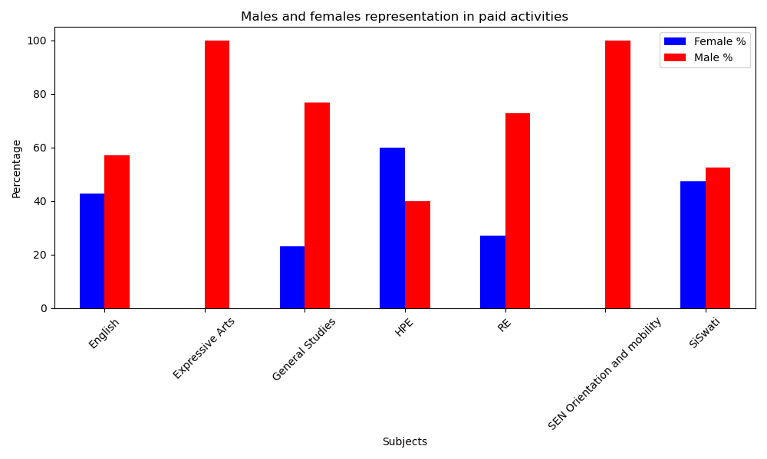
Based on the bar graph showing gender representation across subjects for Grades 1 and 2 combined, several key patterns emerge regarding the representation of males and females. In subjects like HPE and SiSwati, there is a relatively balanced gender distribution. HPE has a higher percentage of females at 60%, while SiSwati is nearly equal, with 47.37% females and 52.63% males. This shows that both genders are evenly represented in these subjects. English also demonstrated a moderate balance, though males slightly outnumbered females (57.14% male vs. 42.86% female).
In contrast, subjects like GS and RE showed a significant male representation. GS had 76.92% male representation, and RE followed closely with 72.73%. These disparities suggested that females are underrepresented in these subjects, which may warrant further investigation into potential barriers.
The most pronounced gender imbalances are seen in EA and SEN Orientation and Mobility, where 100% of the representation is male. Subjects such as SEN Braille and SEN Daily Living Skills were excluded from the graph due to a lack of recorded data, indicating no representation from either gender during the reporting period.
Overall, the data highlighted both areas of gender parity and significant imbalances. These insights can inform targeted interventions to promote more equitable representation across all subjects, ensuring that both males and females have equal opportunities to engage and succeed.

MIDDLE PHASE: MALES AND FEMALES IN PAID ACTIVITIES
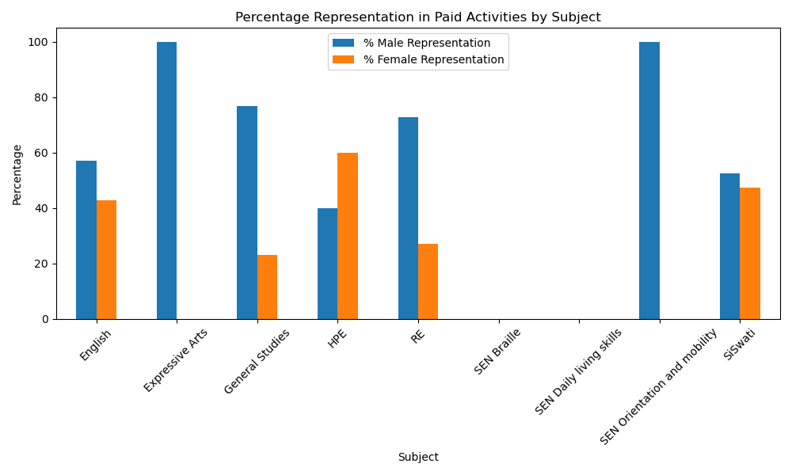
The analysis of paid activities across different subjects showed that males are generally more represented than females, although the level varies by subject. In subjects such as EA, GS, RE, and SEN Orientation and Mobility, male representation reaches or exceeds 70%, with some, like EA and SEN Orientation and Mobility, showing 100% male representation. This suggests that in these areas, males are either more often assigned paid tasks or are more likely to participate in them.
English and SiSwati had a more balanced distribution, with male representation around 57% and 53%, respectively. This indicates a fairly equal sharing of paid responsibilities between males and females in these subjects. In contrast, HPE is the only subject where female representation exceeds that of males, with 60% of the paid activities performed by females. This exception highlights how gender dynamics in task distribution can vary widely depending on the subject.
Notably, SEN Braille and SEN Daily Living Skills recorded no paid activities for either gender, which may reflect the nature of the subjects or a lack of representation in those areas. Overall, the data indicated a trend of male dominance in paid activities, with a few exceptions.
UPPER PHASE: MALE AND FEMALE IN PAID ACTIVITIES
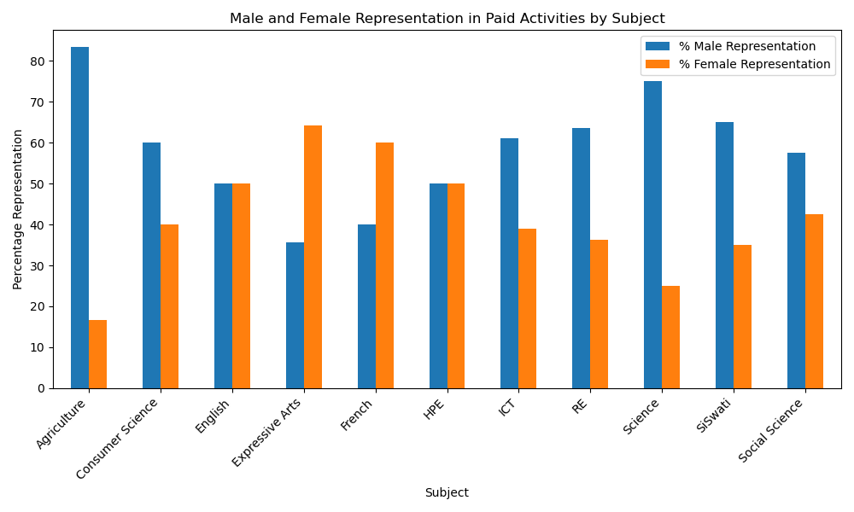
The analysis of paid activities across various subjects revealed significant gender differences. In subjects such as Agriculture, Science, and SiSwati, males predominantly occupy paid roles, accounting for 83.33%, 75.00%, and 65.00%, respectively. These numbers suggested that males are more frequently assigned or take on paid roles in these areas, likely influenced by traditional gender expectations. Subjects like RE, ICT, and Consumer Science also show higher male participation, ranging from 60% to over 63%. This trend indicated that males generally have a greater presence in paid activities across different subjects. In contrast, EA and French have a more balanced or female-leaning distribution, with females making up 64.29% in EA and 60.00% in French.
Interestingly, English and HPE showed perfect gender balance, with both males and females represented equally in paid activities. This parity highlighted the potential for fair activity sharing when roles are assigned without bias. Overall, the data emphasized the need to promote gender equity in the distribution of paid activities within instructional materials. While some subjects demonstrated balanced participation, others revealed significant disparities that may reinforce traditional gender expectations. Addressing these imbalances can help create a more inclusive and fair learning environment for all.

MIDDLE PHASE: MALES AND FEMALES IN UNPAID ACTIVITIES
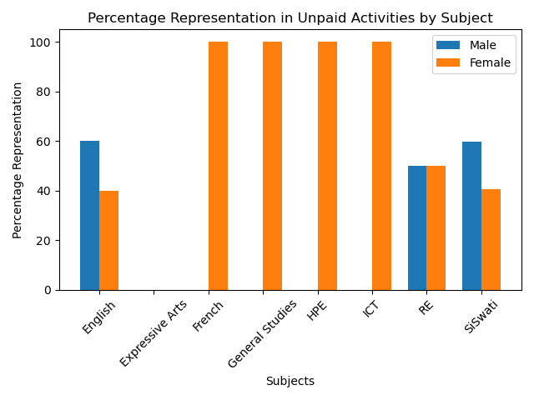
The analysis of unpaid activities across different subjects reveals clear gender differences in representation. In subjects like English and SiSwati, males are more involved in unpaid activities, accounting for approximately 60% of overall representation. This suggested that males tend to engage more in unpaid activities. Conversely, subjects such as French, GS, HPE, and ICT show a significant difference, with females represented in 100% of unpaid activities. The greater representation of females in these subjects may reflect traditional gender roles or expectations that influence the distribution of tasks between males and females.
Interestingly, RE is the only subject with equal representation from males and females, indicating a balanced approach to task sharing in this area. Meanwhile, EA showed no recorded unpaid activity for either gender. Overall, the data highlighted the need for a more equitable distribution of unpaid responsibilities in educational settings. Promoting balanced representation not only fosters fairness but also helps challenge and reshape traditional gender norms from an early age.
UPPER PHASE: MALES AND FEMALES IN UNPAID ACTIVITIES
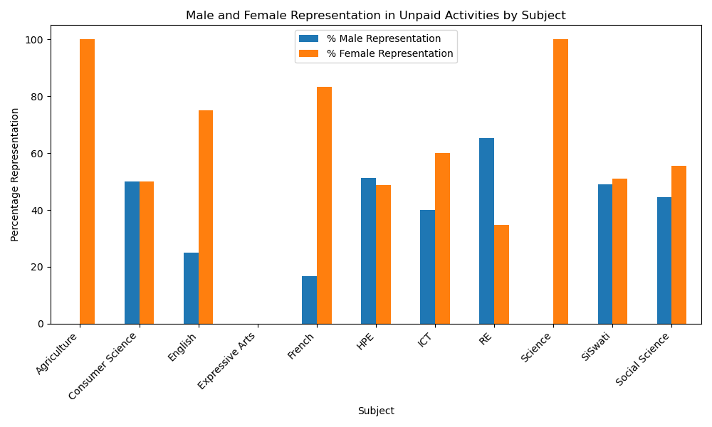
The analysis of unpaid activities across different subjects revealed a varied pattern of gender representation. In some subjects, like Agriculture and Science, unpaid activities are performed exclusively by females, with 100% female representation and no male involvement recorded. This suggests that in these areas, females are more likely to be assigned or take on unpaid responsibilities, possibly reflecting traditional gender roles. In contrast, subjects like Consumer Science show a perfectly balanced distribution, with both males and females represented equally in unpaid activities. This balance is also nearly achieved in SiSwati and HPE, where male representation is approximately 49% and 51%, respectively, indicating a relatively equitable sharing of responsibilities.
However, other subjects showed a more uneven distribution. For instance, RE had a higher male representation, with over 65% of unpaid activities performed by males. Similarly, ICT and Social Studies had male representation at 40% and 44%, respectively, indicating a moderate gender gap in these fields. French and English had more female representation, with male representation at just 17% and 25%, respectively. Meanwhile, EA recorded no unpaid activities for either gender, which may suggest a lack of such activities in the instructional materials.
Overall, the data highlighted the importance of promoting gender equality in the distribution of unpaid activities in instructional materials. While some subjects showed a balanced representation, others revealed significant disparities that can reinforce traditional gender roles. Addressing these gaps can help create a more inclusive and fair learning environment for all learners.

FOUNDATION PHASE: MALES AND FEMALES AS NURTURES
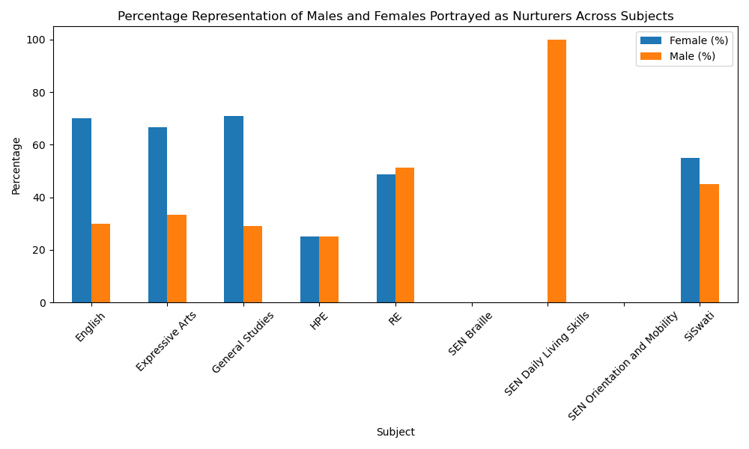
The bar graph illustrates how males and females are portrayed as nurturers across various subjects in the foundation phase. The data reveals a general trend of higher female representation in nurturing roles, although there are some notable exceptions.
Subjects such as English, EA, and GS exhibit a strong female dominance in nurturing depictions, with females comprising approximately 70%, 66.67%, and 70.83%, respectively. These results suggest that traditional views of nurturing as a feminine trait may still influence how roles are depicted in these subjects.
In SiSwati, the representation is more balanced, with females making up 55% and males 45%. RE also showed a close balance, though slightly favoring males at 51.3%, and females at 48.7%. HPE presents an unusual case where both genders are equally represented at 25%, indicating limited overall representation of nurturing roles in this subject, but with no gender bias.
On the other hand, SEN Daily Living Skills is the only subject where nurturing roles are assigned solely to males, with 100% male representation. Subjects like SEN Braille and SEN Orientation and Mobility show no recorded nurturing roles for either gender.
Overall, the graph indicates a trend of associating nurturing roles with females, with some areas exhibiting greater gender balance or male dominance.

MIDDLE PHASE: MALES AND FEMALES AS NURTURES
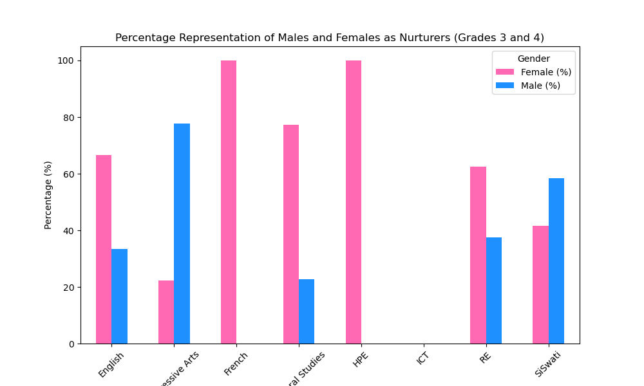
The bar graph above compares how males and females are shown as nurturers across different subjects in the middle phase. The data reveals a varied pattern of gender representation, with some subjects mostly favouring females, others leaning toward males, and a few showing a more balanced portrayal.
French and HPE had 100% female representation, highlighting a strong link between nurturing traits and females. GS and English also had significant female majority representation, at 77.27% and 66.67%, respectively. These figures support the trend of associating nurturing roles more often with females. In contrast, EA showed a significant deviation, with males accounting for 77.78% of nurturing portrayals. In RE, females represented 62.5%, while males made up 37.5%. Meanwhile, in SiSwati, females comprised 41.67%, and men 58.33%. These figures suggest a more inclusive approach to assigning nurturing roles, promoting greater gender equity. ICT showed no recorded representation of nurturing roles for either gender.
Overall, the graph indicates that gender stereotypes persist, yet there are signs of progress toward equality.

UPPER PHASE: MALES AND FEMALES AS NURTURES
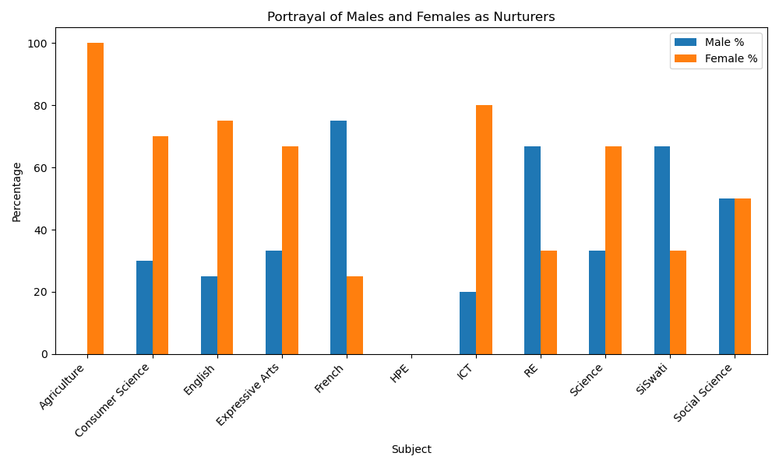
The bar graph, which shows males and females as nurturers across different subjects, highlights a clear gender gap in representation. Overall, females are more frequently depicted in nurturing roles than males.
Subjects such as Agriculture, Consumer Science, English, EA, and ICT exhibit a significantly higher percentage of female portrayals. For example, in Agriculture, females are entirely depicted as nurturers (100%), while males are not represented. Similarly, Consumer Science and English show 70% and 75% female representation, respectively.
French, SiSwati, and RE had higher male representation in nurturing roles, at 75%, 66.7%, and 66.67%. Social Studies showed a gender-neutral representation at 50%. Science and EA had greater female representation at 62% and 63%, respectively. HPE shows no gender difference in nurturing roles.
In summary, the data shows progress in gender balance in some subjects, but stereotypes persist, with females mainly depicted in nurturing roles. This highlights the need for more inclusive portrayals that challenge gender norms

FOUNDATION PHASE: MALES AND FEMALES AS OWNERS OF RESOURCES
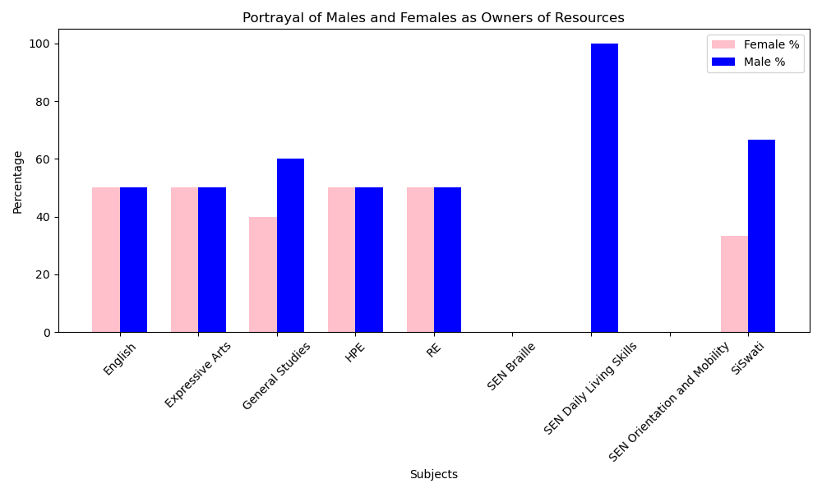
The bar graph indicates balanced gender representation as resource owners across subjects, with some exceptions. Subjects such as English, EA, HPE, and RE show equal numbers of males and females, at 50% each, reflecting efforts toward gender equality.
In General Studies, males are portrayed more (60%) than females (40%), indicating a bias toward male ownership. In SiSwati, males account for 66.67% of resource owner portrayals, while females make up 33.33%. SEN Daily Living Skills shows that males are the sole resource owners (100%). Subjects such as SEN Braille and SEN Orientation and Mobility had no recorded representations for either gender.
Overall, although there is evidence of gender balance in several subjects, the data also highlighted areas where female representation as resource owners is limited or missing.
MIDDLE PHASE: MALES AND FEMALES AS OWNERS OF RESOURCES
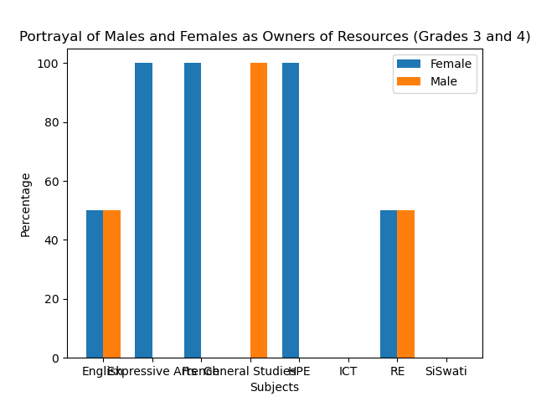
The bar graph illustrates the percentage of males and females represented as resource owners in Grades 3 and 4, highlighting distinct gender patterns across subjects. In English and RE, all genders are equally represented at 50%, reflecting efforts toward gender equity and shared ownership roles.
However, several subjects clearly show gender dominance. EA, French, and HPE feature only females as owners of resources, with a full 100% representation and no male presence. In contrast, General Studies is the only subject where males are exclusively portrayed as owners of resources (100%). Subjects like ICT and SiSwati lack gender representation in ownership roles.
The graph shows progress and gaps in gender representation. Some subjects are balanced, while others reinforce stereotypes or lack representation in resource ownership.
UPPER PHASE: MALES AND FEMALES AS OWNERS OF RESOURCES
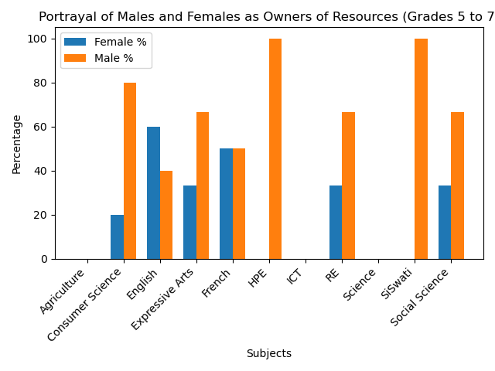
The bar graph shows the representation of males and females as resource owners across the upper phase, showing mixed gender patterns, with some subjects balanced and others displaying disparities.
French depicted a balanced representation, whilst English has a 60% female majority. Consumer Science indicated that males are the owners at 80%, and females are at 20%. Similarly, EA highlights males at 66.67% and females at 33.33%. HPE and SiSwati show complete male dominance (100%).
Subjects like RE and Social Studies show a two-thirds male representation (66.67%) versus one-third female (33.33%), indicating a moderate gender imbalance. Agriculture, ICT, and Science show no gender in ownership roles.
The graph illustrates the state of gender representation across selected subjects, revealing both areas of balance and disparities. While some subjects, such as Religious Education, show a higher proportion of female participation, others, like SiSwati, continue to reflect gender imbalances.

FOUNDATION PHASE: MALE AND FEMALE AS CONTROLLERS OF RESOURCES
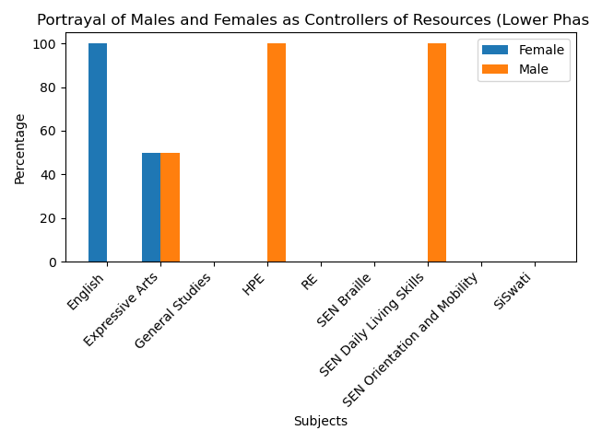
The graph depicts gender disparities in resource control within instructional materials at the Foundation phase.
In English, females are shown as resource controllers, with 100% representation, indicating a strong female presence or influence in this area. EA presents a balanced portrayal, with females comprising approximately 60% and males 40%. General Studies is the most gender-balanced subject, with equal 50% representation of males and females as resource controllers. The trend in SEN subjects, Braille, Daily Living Skills, Orientation and Mobility, HPE, and RE shows that males are the sole resource controllers (100%). Siswati had no representation for any gender.
The graph highlights a gender disparity in the depiction of resource control, with males predominantly portrayed as the primary controllers.

MIDDLE PHASE: MALES AND FEMALES AS CONTROLLERS OF RESOURCES
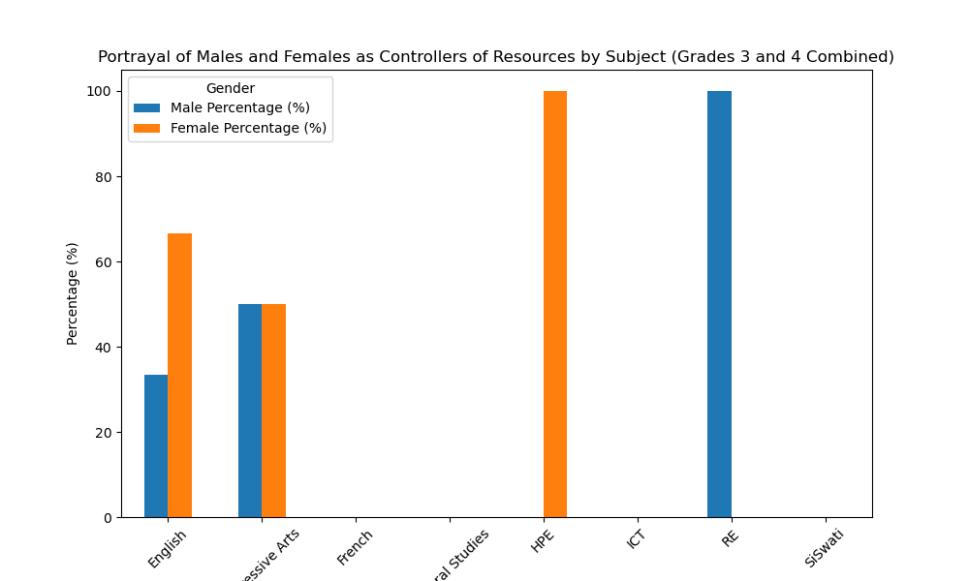
The bar graph, which shows males and females as resource controllers across subjects at the Middle phase, reveals varied representation, with some subjects showing equity and others inequality.
In English, females are more often portrayed as resource controllers at 66.67%, compared to males at 33.33%. EA presents a balanced portrayal, with males and females equally represented at 50% each. In contrast, RE shows a gender imbalance, with 100% male portrayal. HPE flips this trend, showing 100% female portrayal. Subjects such as French, General Studies, ICT, and SiSwati show 0% representation for both genders.
Overall, the graph indicates that while some subjects strive for gender balance or emphasize female representation, others continue to reflect traditional gender roles.

UPPER PHASE: MALES AND FEMALES AS CONTROLLERS OF RESOURCES
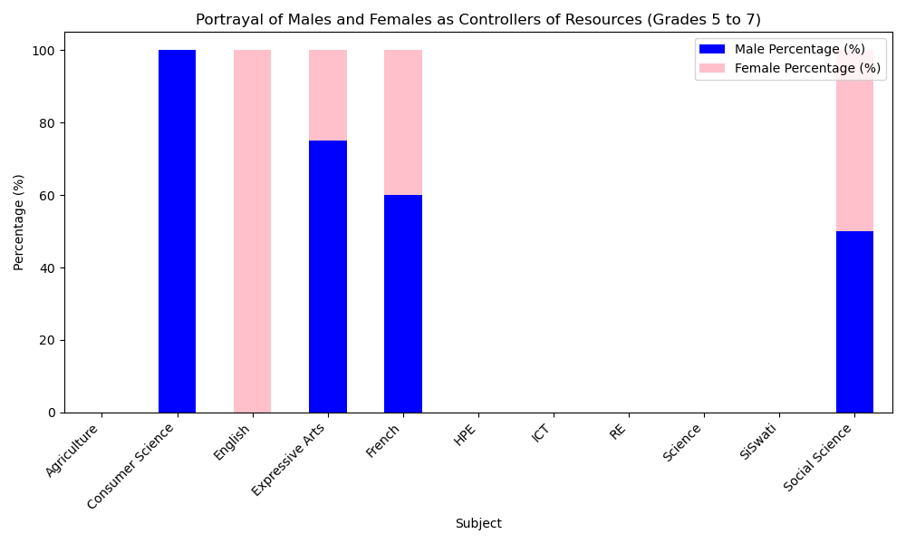

The bar graph illustrates gender distribution among males and females controlling resources in the Upper phase. The data shows that gender portrayal varies across subjects, with some indicating strong gender dominance and others showing balance. For example, English is entirely female-dominated, with 100%. In contrast, Consumer Science is portrayed as 100% male-dominated. EA and French both show a male-dominant portrayal, with 75% and 60% male representation, respectively.
Social Studies stands out as the only subject with equal representation (50% male, 50% female), demonstrating a balanced portrayal of both genders.
Several subjects, including Agriculture, HPE, ICT, RE, Science, and SiSwati, lack representations for either gender.

Overall, the graph shows progress and ongoing gender gaps. Some subjects promote balance or challenge stereotypes, while others reflect norms.

FOUNDATION PHASE: MALES AND FEMALES AS LEADERS
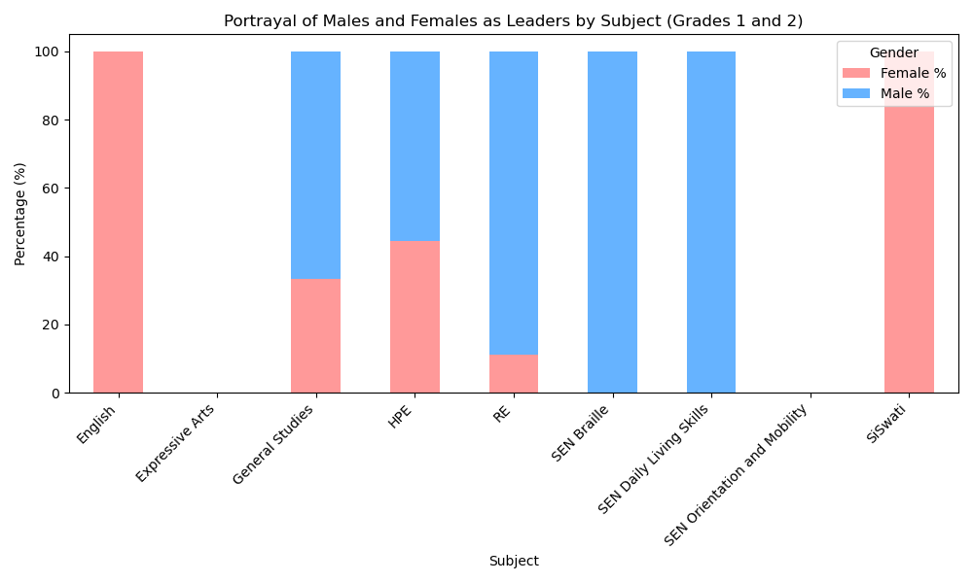
The bar graph above depicting the portrayal of males and females as leaders across subjects in the Foundation phase reveals an apparent gender disparity, illustrating how leadership roles are assigned.
Subjects like English and SiSwati feature a 100% female leadership portrayal, indicating that females are more prominently shown in leadership roles.
Conversely, subjects such as RE and SEN-related areas (including SEN Braille and SEN Daily Living Skills) exhibit a strong male dominance. For example, RE has 88.89% male and only 11.11% female leadership representation, while SEN Braille and SEN Daily Living Skills are entirely led by males at 100%.
GS and HPE display a more balanced gender distribution, with GS comprising 33.33% female and 66.67% male, and HPE consisting of 44.44% female and 55.56% male. These subjects may provide more opportunities for gender-inclusive representation, although males still slightly predominate.
EA and SEN Orientation and Mobility show 0% representation for both genders, suggesting either a neutral portrayal or an absence of leadership depiction. Overall, the graph shows males primarily as leaders in early education.
MIDDLE PHASE: MALES AND FEMALES AS LEADERS
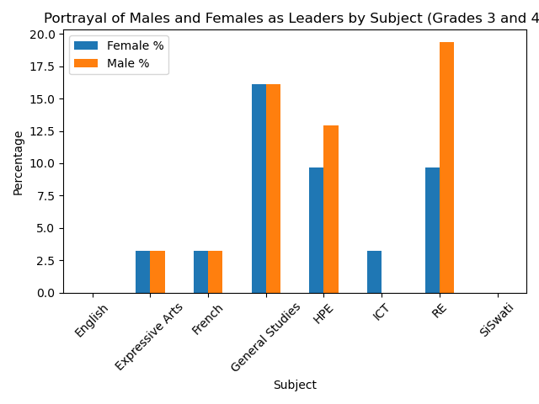

KUNENKINGA KU % out of 20 review
The above bar graph shows the portrayal of males and females as leaders across subjects in the Middle Phase. It reflects both balance and disparity depending on the subject.
Overall, males are portrayed slightly more often as leaders, with 54.84% portrayals compared to 45.16% for females. This difference, although not substantial, suggests a slight tendency toward male leadership representation in certain subjects.
Subjects like GS present a balanced view, with 16.13% for males and females each. This reflects an equitable depiction of leadership roles in a subject that often covers civic and societal themes.
RE exhibits the highest male leadership representation at 19.35%, while female representation stands at 9.68%. This disparity may mirror traditional narratives that associate religious authority more frequently with males.
In HPE, males are also more prominently portrayed (12.90%) than females (9.68%), although the gap is smaller. This could indicate a more inclusive approach in topics related to health and physical development.
Subjects like EA and French show equal representation, with 3.23% each for both genders, indicating a balanced but limited portrayal of leader.
ICT presents a unique case where females are portrayed (3.23%) but males are not, challenging common stereotypes and suggesting a progressive depiction of female leadership in technical domains.
Notably, English and SiSwati lack portrayals of leadership for either gender, which may suggest a neutral presentation or an absence of focus on leadership roles within the curriculum content for these subjects.
Overall, the graph shows that while some subjects aim for gender balance in leadership portrayals, others still reflect traditional gender roles. The presence of female leadership in ICT and balanced representation in General Studies are positive signs, but the dominance of male portrayals in RE and HPE indicates there is still room for improvement. Promoting equitable and diverse leadership representation across all subjects is crucial for creating inclusive educational environments from early grades.

UPPER PRIMARY PHASE: MALES AND FEMALES AS LEADERS
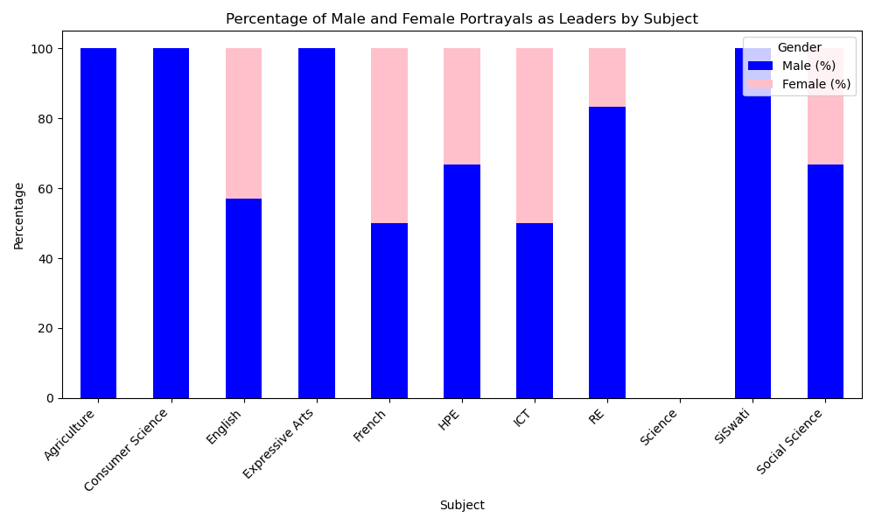
The analysis of male and female portrayals as leaders across various subjects in the Upper Phase reveals a significant gender disparity, with males more frequently depicted in leadership roles.
This trend is evident in subjects such as Agriculture, Consumer Science, EA, and SiSwati, where males are depicted as leaders exclusively. These subjects demonstrate 100% male representation.
In contrast, subjects such as French and ICT present a more balanced view, with equal representation of both genders at 50%. English also shows a relatively high female representation at 42.9%, followed by HPE and Social Studies, each with 33.3% female portrayals. However, the absence of any leadership portrayals in science is notable.
Overall, the underrepresentation of female leaders in various fields may limit learners' perceptions of leadership potential and perpetuate outdated gender norms.

FOUNDATION PHASE: MALES AND FEMALES REPRESENTED AS VICTIMS
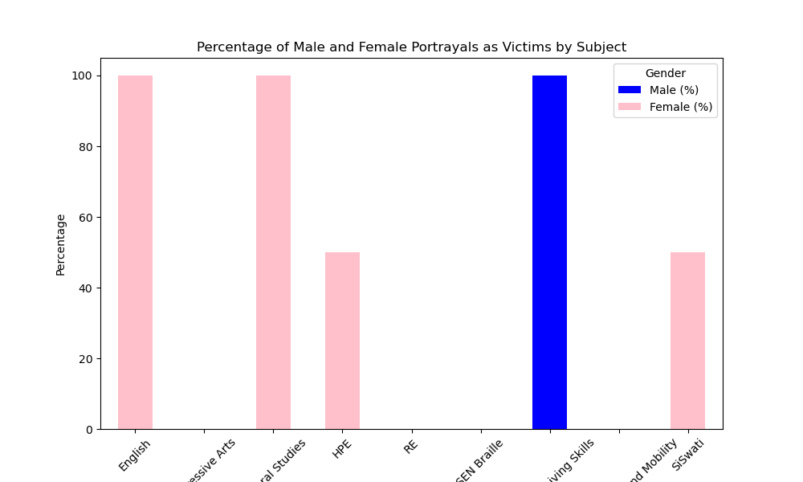
The above graph provides an analysis of the representation of males and females as victims across different subjects in the Foundation phase. According to the data, females are more often depicted as victims in several subjects, although the overall gap between male and female victim portrayals is not as significant.
Subjects such as English and GS show a complete dominance of female victim portrayals, with 100% of the victim roles represented by females. This is followed by HPE and SiSwati, where the portrayal is more balanced, with 50% of the victim roles represented by females.
SEN Daily Living Skills is the only subject where 100% of the victim portrayals are male. Several subjects, including EA, RE, SEN Braille, and SEN Orientation and Mobility, exhibit no portrayals of victims whatsoever.
Overall, the data suggests that while there is some diversity in how victimhood is portrayed across subjects, there remains a tendency to depict females more frequently in these roles.

MIDDLE PHASE: MALES AND FEMALES REPRESENTED AS VICTIMS
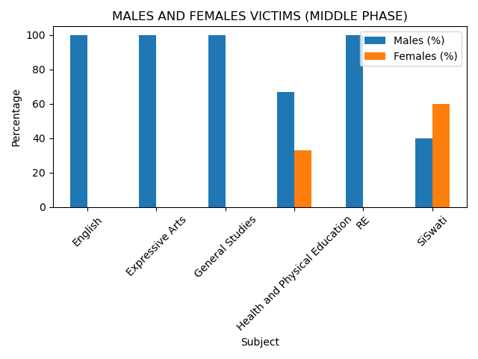
The above graph provides an analysis of the representation of males and females as victims across different subjects in the Middle phase. The data shows that male learners are mostly listed as victims in most subjects, while female representation is minimal or missing in several areas.
In subjects such as English, EA, GS, and RE, males account for 100% of the portrayed victims. HPE shows a more imbalanced representation, with 67% males and 33% females.
SiSwati is the only subject where females outnumber males, with 60% of victims being female compared to 40% males. Subjects like French and ICT did not record any instances of gender-based victim portrayal.
Overall, the graph highlights a strong male predominance in victim representation across most subjects, with only isolated cases of female prevalence.
UPPER PHASE: MALES AND FEMALES REPRESENTED AS VICTIMS
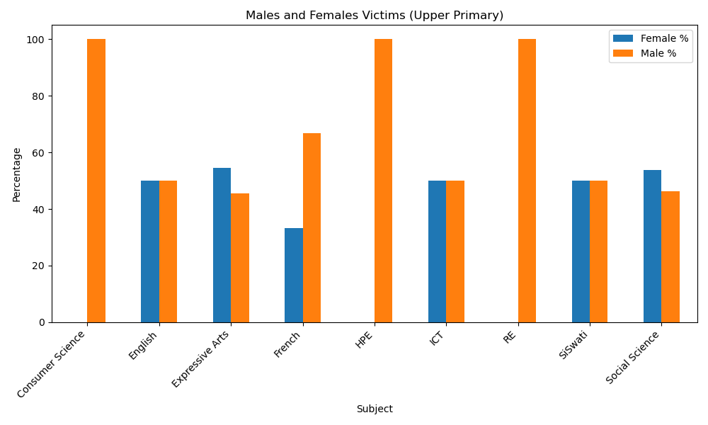
The graph above provides an analysis of the representation of males and females in various subjects. Males are depicted more often as victims. For example, in Consumer Science, males in HPE and RE represent 100% of reported victim cases.
On the other hand, females are more often portrayed as victims in subjects like EA and Social Science, where they account for approximately 54.55% and 53.85% of the cases, respectively. Subjects such as English, ICT, and SiSwati exhibit balanced representation, with each gender comprising 50%. In French, males are more frequently portrayed as victims (66.67%), while females make up 33.33%. Agriculture and Science show no reported cases for either gender.
Overall, the graph shows that males are more often depicted as victims across many subjects, although there are exceptions where females are represented equally or more.
FOUNDATION PHASE: MALE AND FEMALE IN COMMUNITY ACTIVITIES
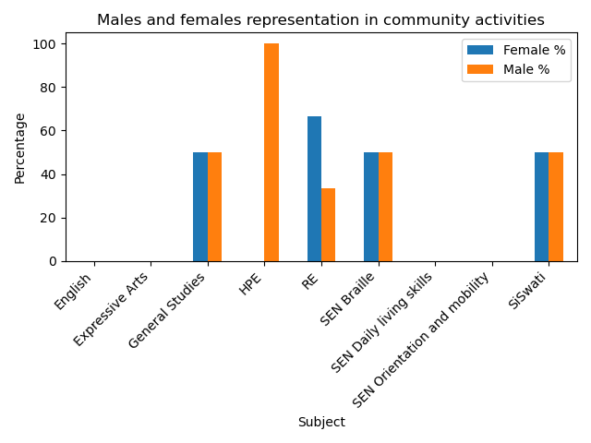
The bar graph illustrates the percentage representation of males and females involved in community activities across various subjects in Grades 1 and 2 combined
In GS, SEN Braille and SiSwati, there is a perfect gender balance, with both males and females represented equally at 50% each. RE stands out with a higher female representation at 66.67%, compared to 33.33% male. Conversely, HPE exhibited a stark gender disparity, with 100% male representation and no recorded female representation.
Furthermore, subjects including English, EA, SEN Daily Living Skills, and SEN Orientation and Mobility exhibited no recorded representation from either gender in community activities.
Overall, the data shows promising progress toward gender parity in certain subjects, while highlighting areas where focused efforts could foster more balanced representation. Addressing these gaps can help achieve the goal of making community activities more inclusive and beneficial for all learners.
MIDDLE PHASE: MALES AND FEMALES IN COMMUNITY ACTIVITIES
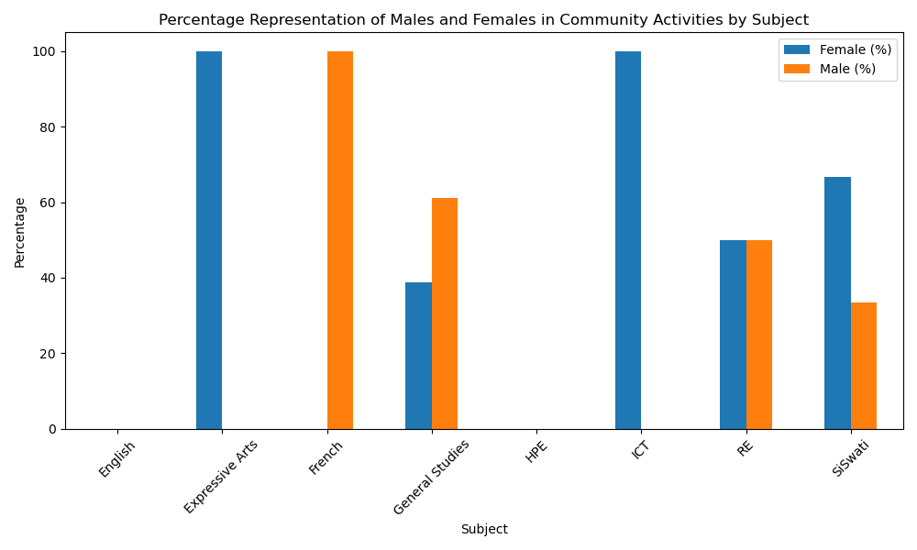
The bar graph displays the percentage of male and female representation in community activities for Grades 3 and 4 across various subjects. It highlights trends and gender disparities. RE is the only subject with equal representation, with both males and females at 50%.
In contrast, specific subjects are dominated by one gender. EA and ICT are exclusively represented by females, with women making up 100% of the participants and no males involved. Similarly, SiSwati shows a higher female representation, with two-thirds (66.67%) of the participants being female and one-third (33.33%) male. French representation is solely male, indicating a gender imbalance in community involvement. Likewise, GS favours male participation, with 61.11% male and 38.89% female participants, reflecting a moderate gender disparity. English and HPE had no recorded community activity participation for either gender.

UPPER PHASE: MALES AND FEMALES IN COMMUNITY ACTIVITIES
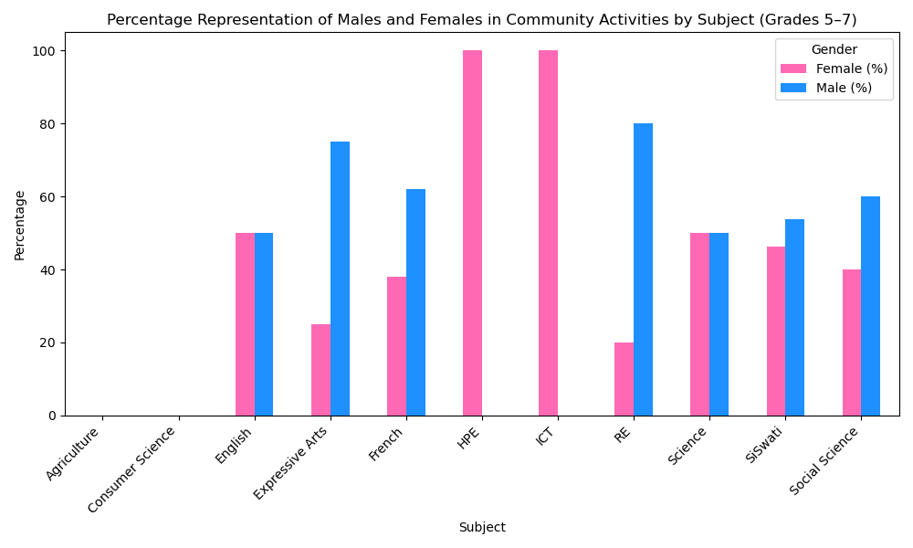
The bar graph illustrates a comparison of the participation of males and females in community activities across various subjects for Grades 5 to 7. English and Science show equal representation from both males and females, with each group making up 50% of the representation.
In contrast, HPE and ICT are exclusively represented by females, with 100% female representation. Conversely, RE and EA are mostly male-dominated, with male representation at 80% and 75%, respectively. French, SiSwati, and Social Studies show a more moderate imbalance. In French, males make up about 62%, while females account for roughly 38%. SiSwati and Social Studies also lean slightly toward male representation, with males representing 53.85% and 60%, respectively.
Agriculture and Consumer Science show no recorded representation from either gender, which may point to a lack of community activities in these subjects.
Overall, the graph highlights both areas of gender parity and disparity, offering valuable insights for educators and policymakers aiming to promote inclusive representation in community activities across all subjects.

